Bradley Reardon

Time Series Forecasting and Analysis

HW4

Question 2:

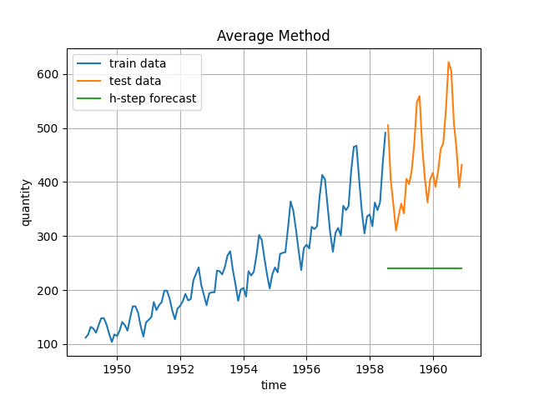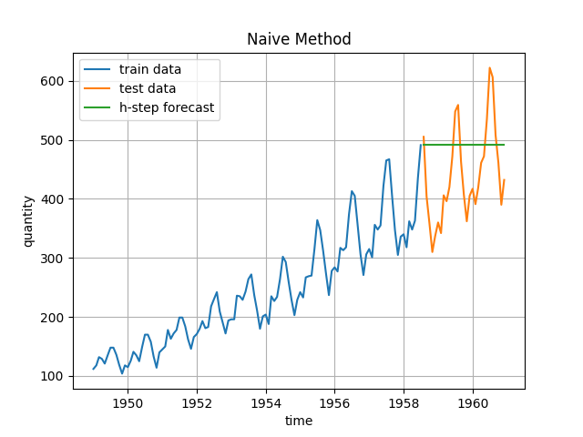

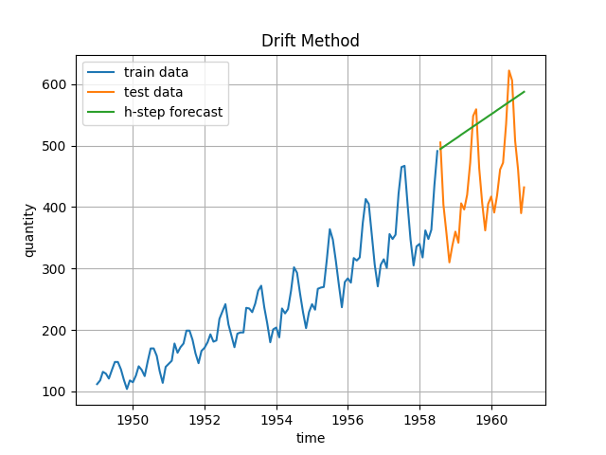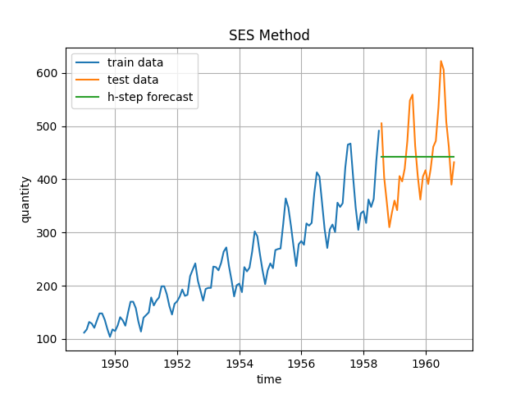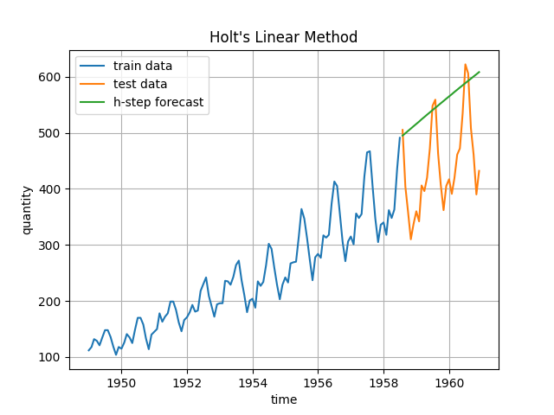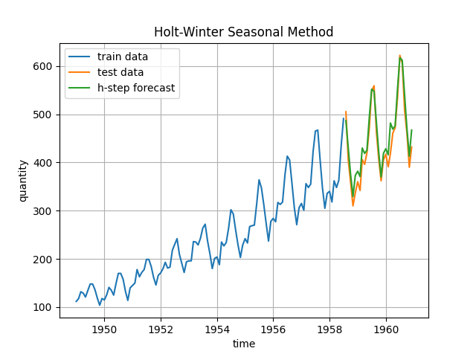

Question 3, 4, 6, 7:

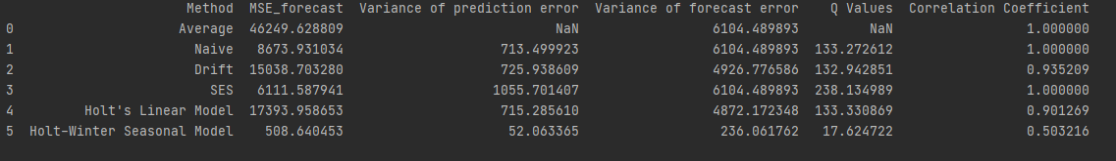

The variance of prediction error is much lower than the variance of forecast error.

The correlation coefficient is nearly 1 for all tests other than Holt-Winter seasonal model, meaning the errors are highly correlated for those near 1.

As we can observe in the plots, the Holt-Winter seasonal model performs the best at forecasting data, and can also be observed by noting it has the smallest MSE value.

Question 5:

